[](https://www.bing.com/images/search?view=detailV2&ccid=Eb1bC4Qu&id=1FED6AC58B9E4B05EBB4B5D55A3DF5F9842BBA59&thid=OIP.Eb1bC4Qu1bBMQcWmpJLcgwAAAA&mediaurl=https%3a%2f%2fi.guim.co.uk%2fimg%2fstatic%2fsys-images%2fGuardian%2fPix%2fpictures%2f2012%2f7%2f15%2f1342377064625%2fCharity-collection-boxes-008.jpg%3fwidth%3d300%26quality%3d85%26auto%3dformat%26fit%3dmax%26s%3d4cc582ae55e14329a7bfc5f91f2a4455&exph=180&expw=300&q=charity+street+collections&simid=607999809211336290&selectedIndex=8)A box with red poppies and a can of red juice



**Chelmsford City Council**

Street Collection

Policy

**2023 - 2028**

Implemented Date…………….

## CONTENTS

Section

1. The Law
2. Definition of the policy
3. Scope of the policy
4. Permit Requirements
5. Collectors Behaviour
6. Registered Charities and Charitable Organisations
7. Exceptions
8. Hearing Procedure
9. Proceeds Statement form
10. Offences and Penalties
11. Appendices

|  |  |  |
| --- | --- | --- |
| Public Places | Date Produced: | 28/03/2024 |
| Public Health and Protection Services | Last Reviewed: | October 2018 |
| Ref & Issue No: | 4 |
| Licensing | Next Review Due: | October 2028 |
| Originating Officer: | Daniel Winter |
| Policy in respect of Street Collections | Authorised By: | Keith Nicholson |
|  | Director of Public Places |

**Aim of Policy**

The aim of this policy is to:

* + ensure members of the public know which organisation they are donating to and to ensure all monies collected are given to the correct charity or charitable organisation.
  + ensure all monies collected are given to registered charities and unregistered organisations who prove their charitable purposes.
  + Control the number of charitable collections on any day to ensure visitors to Chelmsford City are not repeatedly being approached to donate monies to several organisations on the same date and
  + ensure collectors act in a civil, polite, and orderly manner.

1.1.

**The Law**

Chelmsford City Council has local regulations in place regarding street collections and the sale of items for charitable purposes. These were made under powers conferred by the Police, Factories etc. (Miscellaneous Provisions) Act 1916 (as amended). This policy should be read in conjunction with the regulations, a copy of which is attached at **Appendix A**.

* 1. The regulations mean that anyone wishing to make a public collection or sell articles for a charitable purpose must first have a Street Collection Permit from the local authority in whose area it wishes to collect. Amongst other things, this process enables a local authority to ensure that the organisation is legitimate and to regulate the method of collection and the number of collections that are taking place at any one time.
  2. Any person/organisation who is dissatisfied with the refusal of an application for a street collection permit may request that the application be considered formally by the Council’s Regulatory Committee. This must be done in writing within 21 days of the date of the refusal letter and must state the grounds on which the review is being requested.
  3. The Act does not make provision for legal appeals against the decision of the Council in relation to the refusal of Street Collection Permits. Should a person aggrieved by a decision of the Council feel it necessary, they may seek a Judicial Review of the decision.
  4. Formal action may be taken if any organisation fails to present a properly completed statement form detailing the amount collected and other matters as required by the Regulations (Copy of this form is **Appendix B**).

1. **Definition of a Street Collection**
   1. A street collection is defined as a collection of monies that takes place on “street”. This includes any highway and any public bridge, road, lane, footway, square, court, alley, or passage, whether a thoroughfare or not. A permit is also required if collections are made in car parks or shop doorways.
   2. For those wishing to collect on private property i.e. within a store/supermarket etc. a permit is not required by the local authority. Permission should be sought from the landowner/store proprietor before commencement of a collection.
   3. Where a charitable collection takes place outside a premises, on a premises frontage or in a car park, even if the outside area is in private ownership, a street collection permit would be required together with the consent of the store manager/landowner.
2. **Scope of Policy**
   1. This policy affects any person, society, committee, or other body of persons responsible for any collection of money or sale of any article for charitable purposes in any street or public place within the Chelmsford District. Permits will be issued in line with this policy and granted for a specific date for a specified locality. Operating outside the conditions of the permit or the requirement of the regulations will be an offence.
   2. The regulations, and therefore this policy, do not extend to:
      * collections or sale of articles for charitable purposes in non-public places
      * collections made incidental to meetings held in the open air.
      * the selling of articles in the ordinary course of trade, and for the purpose of earning a livelihood, and no representation is made by or on behalf of the seller that any part of the proceeds of the sale will be devoted to charitable purposes.
   3. The grant of a permit to collect does not absolve the applicant of his or her responsibilities to the public. All applicants for a street collection permit should be aware of their need to ensure that they have adequate insurance and public liability cover. If applying to collect in the city centre, it is advisable to contact the City Centre Management team to ensure that their permitted day does not conflict with any other activity occurring in the area.
   4. The grant of a permit does not allow the placing of any vehicle as this would potentially cause an obstruction on the Highway, however the use of a stand, tables, chairs, items of equipment or independent display material may be allowed providing permission is obtained from the City Centre Management team beforehand.

The policy will be implemented by the Licensing Section of Public Health and Protection Services.

1. **Applying for a Street Collection Permit**

POLICY ON APPLICATIONS FOR CHARITABLE COLELCTIONS

* 1. Chelmsford City Council will require all applicants to first secure permission and schedule their preferred collection date with any relevant company or organisation responsible for the location concerned, before applying for a permit from the Licensing Department. For collections within Chelmsford City Centre, this will be from the Town Centre Management team. In some circumstances written permission will be required. All applications must be accompanied by the relevant permission, uploaded as a supporting document to their application. A copy of the application is included as **Appendix C.**
  2. All applications must be submitted via the Council’s approved online application process. Any application that is not completed in full will not be processed. Notification of this will be emailed to the applicant.
  3. An application must be made no less than one calendar month and no more than three calendar months before the proposed collection date. We will not accept applications submitted outside this time unless there are exceptional circumstances.
  4. We will not issue a permit to any organisation or body if a return has not been received in relation to any permit granted in any previous year.
  5. We won't consider applications for the following year unless the requested collection date falls within the first three months of that year. If so, applications must be submitted before October of the preceding year. This prevents collectors from booking too far in advance at peak times of the year.
  6. We will accept and process applications on a first come, first served basis. This is to ensure that all charities, whether large or small, have equal access to popular collection dates.
  7. We will issue a maximum of 4 collections permits per calendar year (January to December) for each organisation or individual and only one of those collections can cover two consecutive days.
  8. We will not issue a permit for a location where it may give rise to obstruction. Any person or item

positioned and causing an obstruction will be relocated.

* 1. Collections must not begin before 9am Monday to Saturday or 10am on Sundays and bank holidays or continue after 7pm on any day.
  2. In considering any application, we will have due regard to any request or conditions made by a landowner in respect of applications for permits on private land.

**Policy on the issue of Street Collection permits in Chelmsford City Centre**

* 1. Collection permits will be issued for Saturdays and Sundays only from 1st January to 31st November (inclusive). Collection permits may be issued for any day of the week in December.
  2. Only one street collection permit will be issued for the Chelmsford City High Street area at any time, however exceptional circumstances could apply.
  3. Only one collection permit will be issued in each area (zone) of the town centre outside the High Street at any one time. These zones include High Chelmer Shopping Centre, Meadows Shopping Centre and Bond Street as shown in **Appendix D**.
  4. Applications for street collection permits outside the above city centre zones will be issued, however, each charity is limited to one permit per area, twice a year. These areas cover Moulsham Street, Chelmsford Parks, and other streets within the district.
  5. We will not permit anyone to assist or take part in any collection without the written authority of the society, committee, or other body to whom a permit has been granted.
  6. We will only permit a maximum number of 6 collectors for any collection unless exceptional circumstances apply. If more than 6 are required for collections on the High Street, then prior approval is required from the Town Centre Management team. All collectors must be over the age of 16 or supervised by an adult if under the age of 16.
  7. We will not charge for the issue of a permit for a street collection. We have a Public Spaces Protection Order (PSPO) in place in Chelmsford city centre, which means you are not allowed to distribute free literature in the High Street, such as flyers or leaflets.

1. **Collectors Behaviours**
   1. During fundraising, avoid actions that may startle or distress the public, act dishonestly, manipulate donors, or damage the organisation's reputation. This includes behaviours like smoking or drinking alcohol while wearing charity-branded clothing, using illegal drugs, being lewd or aggressive, pressuring donations, exploiting one's position, or any behaviour harming the organisation's reputation. Enforcement action may be taken under the PSPO, potentially resulting in a fine of up to £1000.
   2. Do not cause obstruction, congestion, or nuisance to the public, and do not block pathways.
   3. Do not mislead the public by suggesting conversations are not about fundraising.
   4. Avoid approaching seated individuals or those in unrelated queues unless authorised by private site agreements.
   5. Refrain from approaching individuals engaged in official duties or working.
   6. Do not interfere with or disrespect staff from local businesses.
   7. You must not position yourself within three meters of:
      * a shop entrance;
      * a pedestrian crossing;
      * a cashpoint machine;
      * a station entrance;
      * a market stall; or
      * a street trader, vendor or busker.
   8. Where a collection box is being carried it must not be shaken.
   9. All collecting boxes, receptacles or trays must prominently display the name of the charity/fund for which they are collecting for.
      1. No payment or reward shall be made or given to any collector or vendor directly or indirectly, or to any person connected with the promotion or conduct of a collection, 100% of the monies collected must be given to the society/charity for which the collection was obtained.
      2. Collectors who are also members of the Public Fundraising Regulatory Association (PFRA) must adhere to the Activity Code of Fundraising Practice on face-to-face fundraising. Failure to comply could result in the refusal of further permits issued by Chelmsford City Council
      3. Members of the public who have experienced any behaviour that contravenes the guidelines outlined in sections 5.1 to 5.6 are encouraged to lodge a complaint. Complaints should be submitted through our online complaints form, which can be accessed on our website.
2. **Registered Charities and Charitable Organisations**
   1. Chelmsford City Council will consider applications from registered charities and a registered charity number will need to be provided on the application form.

6.2. Should the collection be on behalf of a registered charity then a letter of authority will be required which must accompany the application from the organisation.

1. **Exceptions**
   1. Chelmsford City Council reserves the right to deviate from this policy where it is satisfied that there is sufficient cause for doing so.
   2. A general exception to this policy is applied in respect of:
      * Royal British Legion Poppy Appeal. No permit is required.
      * RAFA (the Royal Air Force Association) will be granted a permit for a street collection for its Wings Appeal on the Saturday following the 15th of September (Battle of Britain Day) – or on the 15th if that date falls on a Saturday.
   3. In an exception to the policy restricting the number of permits for any organisation to 4 per calendar year, collection permits may be granted to the Salvation Army for collections in December by the Salvation Army Band, if the relevant permissions have been granted by the landowners/town centre management team and the application is duly made.
   4. Other exceptions to the policy may be made in the following circumstances and will require a written request to the Public Health and Protection Services Manager.

* Response to natural disasters (e.g. earthquakes/tsunamis)– an application may be made outside the normally required time.
* Collections for national charitable events such as Children in Need, Red Nose Day and Sports Relief are discouraged as the organisers themselves prefer sponsored events however, if the relevant permission has been obtained from the landowner or Town Centre Management team, a permit will be granted (even if another collection permit has already been granted in that location)
  1. An organisation may make representations by letter or email to the Public Health and Protection Services Manager at Chelmsford City Council, to request a deviation from policy. This will only be granted if there are significant and material reasons for doing so.
     + **Requirements imposed by other parties**.

When public places are under private ownership, we will issue a permit with the permission of the landowner. The landowner may stipulate conditions to which this authority will abide. We are currently aware of the following restrictions regarding privately owned land:

* + - Asda, South Woodham Ferrers: only allows one collection per month and no collections for animal charities are permitted.

1. **HEARING PROCEDURE**
   1. Where Licensing Services are unable to issue a permit to an applicant, for example if the applicant has a dishonesty related conviction, then the application would need to be determined by the Regulatory Committee.
   2. Where an application is to be considered by the Regulatory Committee the applicant will be notified of the time and date of the hearing.
   3. Prior to the hearing, all parties will be supplied with a copy of the report. The report will contain a summary of the application, representations, and any other relevant information.
   4. At the hearing, all parties will have the opportunity to address the Regulatory Committee and ask questions of fact from other parties. The Regulatory Committee may also ask questions from all parties that they feel are relevant to the determination process.
   5. The Regulatory Committee will communicate their decision to the legal and democratic team after the hearing. All parties will receive written confirmation as soon as is practicable and within 5 working days
2. **PROCEEDS STATEMENT FORM**
   1. Within one month after the date of any collection or sale, the person, society, committee, or other body of persons responsible for the collection shall forward to Chelmsford City Council Licensing Authority, a statement in the form set out in the Schedule to the Regulations, unless there are multiple collections in the same month, in which case the return must be submitted to the Licensing Authority within one month of the final collection. This form will be attached to the permit when it is granted. An example is attached as **Appendix B**
3. **OFFENCES & PENALTIES** 
   1. This document should not be relied upon as an accurate statement of the law, only indicative of the general offences and penalties. You should seek independent legal advice if you are unsure of any information in this document.
   2. Any person who acts in contravention of the Street Collection Regulations will be liable on summary conviction to a fine not exceeding Level 1 on the Standard Scale (currently £200).

DEFINITIONS

*Collection* means a collection of money or a sale of articles for the benefit of a charity or other purposes and the word “collector” shall be interpreted accordingly.

*Promoter* means a person who causes others to act as collectors.

*Licensing Authority* means Chelmsford City Council.

*We* means Chelmsford City Council.

*Permit* means a permit for a collection.

**Comments and Review**

This policy will be subject to review at 5-year intervals unless there is a change in legislation or guidance is issued that might affect elements of this policy before that time. Anyone wishing to comment on this policy may do so in writing to the Public Health and Protection Services Manager, Chelmsford City Council, Civic Centre, Duke Street, Chelmsford Essex CM1 1JE or via the Council’s Comments, compliments, complaints page on the Council’s website at [www.chelmsford.gov.uk](http://www.chelmsford.gov.uk/)

From time to time and should the need arise, the Director of Public Places, in consultation with the relevant Cabinet Member or Chair, is authorised to make minor changes to this Policy, in accordance with the General Powers of Competence within Chelmsford City Council’s Constitution.

**LIST OF CONSULTEES**

**Town Centre Management team (TCM) Market Manager Pauline Rider**

**City Centre and Tourism Manager – Phil Chittock Business Compliance Manager – Jane Smith Operations Manager – Lewis Mould**

**High Chelmer Shopping Centre – Jacqui Dunphy & Karen Howard Meadows Shopping Centre – Sue Patel**

**Bond Street Management Team**

**Customer & Business Support Manager – Jo Sylvester Legal Services – William Butcher**

**Democratic Services – Dan Sharma-Bird**

1. **Appendices**

Appendix A: Copy of the Council’s Regulations Appendix B: Copy of form required for the statement of amount received

Appendix C: Application Form

Appendix D: Map to show zones for street collection within Chelmsford City Centre

Signed date (Environmental Services Manager on behalf of Director of Public Places)

# APPENDIX A

STREET COLLECTION REGULATIONS

1. In these Regulations, unless the context otherwise requires—

*“collection”* means a collection of money or a sale of articles for the benefit of charitable or other purposes and the word

*“collector”* shall be construed accordingly;

*“promoter”* means a person who causes others to act as collectors;

*“**the licensing authority”* means Chelmsford City Council;

*“permit”* means a permit for a collection;

*“contributor”* means a person who contributes to a collection and includes a purchaser of articles for sale for the benefit of charitable or other purposes;

*“**collecting box”* means a box or other receptacle for the reception of money from contributors.

1. No collection, other than a collection taken at a meeting in the open air, shall be made in any street or public place within the **District of Chelmsford** unless a promoter has obtained a permit from the licensing authority a permit.
2. Application for a permit shall be made in writing not later than one month before the date on which it is proposed to make the collection:

Provided that the licensing authority may reduce the period of one month if satisfied that there are special reasons for so doing.

1. No collection shall be made except upon the day and between the hours stated in the permit.
2. The licensing authority may, in granting a permit, limit the collection to such streets or public places or such parts thereof as it thinks fit.
3. (1) No person may assist or take part in any collection without the written authority of a promoter.

(2) Any person authorized under paragraph (1) above shall produce such written authority forthwith for inspection on being requested to do so by a duly authorised officer of the licensing authority or any constable.

1. No collection shall be made in any part of the carriage way of any street which has a footway:

Provided that the licensing authority may, if it thinks fit, allow a collection to take place on the said carriageway where such collection has been authorised to be held in connection with a procession.

1. No collection shall be made in a manner likely to inconvenience or annoy any person.
2. No collector shall importune any person to the annoyance of such person.
3. While collecting—

(a) a collector shall remain stationary; and

(b) a collector or two collectors together shall not be nearer to another collector than 25 meters:

Provided that the licensing authority may, if it thinks fit, waive the requirements of this Regulation in respect of a collection which has been authorized to be held in connection with a procession.

1. No promoter, collector or person who is otherwise connected with a collection shall permit a person under the age of sixteen years to act as a collector.
2. (1) Every collector shall carry a collecting box.

(2) All collecting boxes shall be numbered consecutively and shall be securely closed and sealed in such a way as to prevent them being opened without the seal being broken.

(3) All money received by a collector from contributors shall immediately be placed in a collecting box.

(4) Every collector shall deliver, unopened, all collecting boxes in his possession to a promoter.

1. A collector shall not carry or use any collecting box, receptacle or tray which does not bear displayed prominently thereon the name of the charity or fund which is to benefit nor any collecting box which is not duly numbered.
2. (1) Subject to paragraph (2) below a collecting box shall be opened in the presence of a promoter and another responsible person.

(2) Where a collecting box is delivered, unopened, to a bank, it may be opened by an official of the bank.

(3) As soon as a collecting box has been opened, the person opening it shall count the contents and shall enter the amount with the number of the collecting box on a list which shall be certified by that person.

1. (1) No payment shall be made to any collector.

(2) No payment shall be made out of the proceeds of a collection, either directly or indirectly, to any other person connected with the promotion or conduct of such collection for, or in respect of, services connected therewith, except such payments as may have been approved by the licensing authority.

1. (1) Within one month after the date of any collection the person to whom a permit has been granted shall forward to the licensing authority—

(a) a statement in the form set out in the Schedule to these Regulations, or in a form to the like effect, showing the amount received and the expenses and payments incurred in connection with such collection, and certified by that person and a qualified accountant;

(b) a list of the collectors;

(c) a list of the amounts contained in each collecting box;

and shall, if required by the licensing authority, satisfy it as to the proper application of the proceeds of the collection.

(2) The said person shall also, within the same period, at the expense of that person and after a qualified accountant has given his certificate under paragraph (1)(a) above, publish in such newspaper or newspapers as the licensing authority may direct a statement showing the name of the person to whom the permit has been granted, the area to which the permit relates, the name of the charity or fund to benefit, the date of the collection the amount collected, and the amount of the expenses and payments incurred in connection with such collection.

(3) The licensing authority may, if satisfied there are special reasons for so doing extend the period of one month referred to in paragraph (1) above.

(4) For the purposes of this Regulation “a qualified accountant” means a member of one or more of the following bodies: —

the Institute of Chartered Accountants in England and Wales;

the Institute of Chartered Accountants of Scotland;

the Association of Certified Accountants;

the Institute of Chartered Accountants in Ireland.

1. These regulations shall not apply—

(a) in respect of a collection taken at a meeting in the open air; or

(b) to the selling of articles in any street or public place when the articles are sold in the ordinary course of trade.

**18.** Any person who acts in contravention of any of the foregoing regulations shall be liable on summary conviction to a fine not exceeding [level 1 on the standard scale]

# APPENDIX B

## FORM OF STATEMENT

[ ] Street Collection [ ] House to House Collection

Name and Address of Person responsible for Collection and/or sale:

Name and Address of the Society benefiting from the collection and/or sale:

Date of Collection or Sale:

**STATEMENT OF INCOME AND EXPENDITURE**

|  |  |  |  |  |  |
| --- | --- | --- | --- | --- | --- |
| Income | Amount | Total | Expenditure | Amount | Total |
| From Collection or Sale as per list of Collectors and Vendors and amounts attached hereto  From other sources Bank Interest Other items, viz  £ |  |  | Printing & Stationery Postages  Advertising  Street Collection Boxes & Carriage  Badges or other adornments Other items (if any)  Disposal of balance (insert particulars)  £ |  |  |

**CONTINUED OVERLEAF**

**CERTIFICATION**

Certified by: Hon. Treasurer Address: -

on the: day of 20

Chairman Certificate and Address of Auditor:

This form must be returned to the Council’s Licensing Section, Public Health and Protection Services at the address at the top of the front page, together with:

1. a list of collectors
2. details as to the content of each collection box/envelope
3. a copy of advertisement placed in local newspaper relating to the collection and/or sale.

APPENDIX C

**STREET COLLECTION APPLICATION FOR PERMIT**

I/WE being the person(s) named in ‘1’ below hereby apply for a permit to make a street collection and/or sale as follows:

|  |  |  |  |
| --- | --- | --- | --- |
| 1 | (a) | Names and address & telephone number, email of person(s) responsible for the collection and/or sale | |
|  | (b) | Position(s) within society |  |
| 2 |  | Name of Charity or Fund for the benefit of which the collection and/or sale is to be made | |
| 3 |  | Address of administrative centre of Charity or Fund |  |
| 4 |  | Objective(s) of Charity or Fund |  |
| 5 |  | Area or areas of Chelmsford City within which it is desired to make the collection and/or sale | |
| 6 |  | If you intend to collect in Chelmsford City Centre, please circle your preferred area for collection from the list:  High Chelmer Meadows High Street Bond Street Moulsham St Parks Other | |
| 7 |  | **Date on which it is desired to make the collection and/or sale** | |
| 8 |  | Hours between which it is desired to make the collection and/or sale | |
| 9 |  | Method to be adopted in making the collection and/or sale (i.e. sale of flags, emblems etc. or collection of money) | |
| Signature of applicant | | | Date |

If you are not in any way directly connected with the Charity named above but are a charitable collection, your attention is drawn to the following: The Law requires that you make the following declaration to each and every person donating to you, that

* + You are not a charity, but you are a charitable collector.
  + You will be making a remuneration from the money you are about to donate.
  + Furthermore, you must indicate the percentage of the monies from the last collection made by you which were donated to charity. Please refer to the notes below.

Once completed, this application must be submitted to the Council’s Licensing Section, Safer Communities, at the address given at the top of the application form not later than ONE MONTH before the date on which it is proposed to make the collection and/or sale.

If the Charity named overleaf has not previously applied for a permit to conduct a collection and/or sale within the Chelmsford City, the following must accompany the application:

1. the aims and objectives of the organisation including any supporting documents, e.g. construction and/or articles of association;
2. details of street collection permits approved or refused (other than with the Chelmsford City Council); and
3. a copy of the organisation’s most recent audited accounts.

If you are not in any way directly connected with the Charity named overleaf but intend to collect on their behalf, you must also submit a letter from the Charity on whose behalf you are collecting authority you to undertake the collection

# APPENDIX D

Map to show four zones for street collection

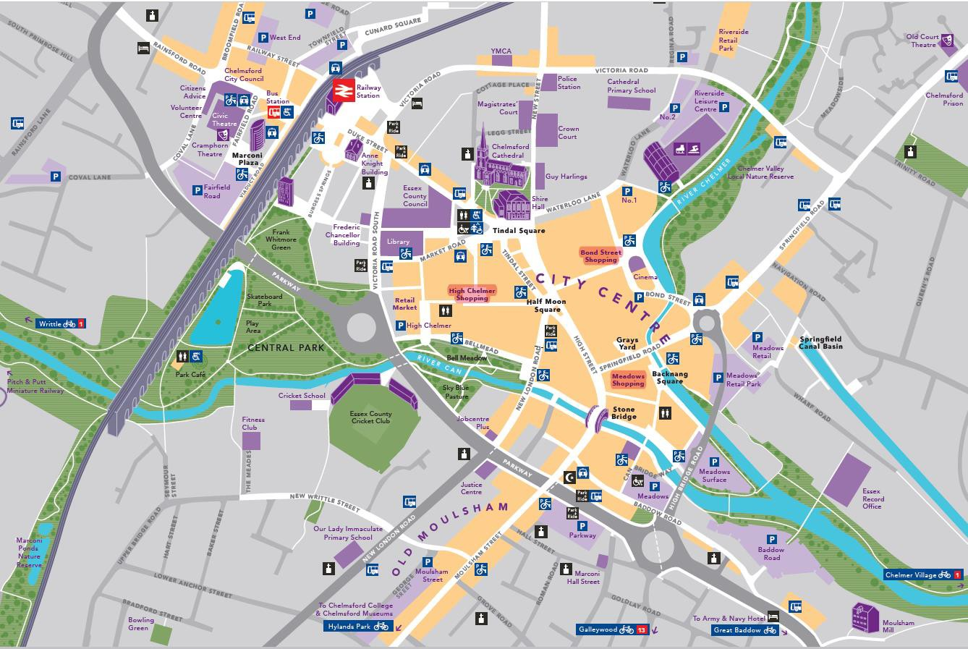

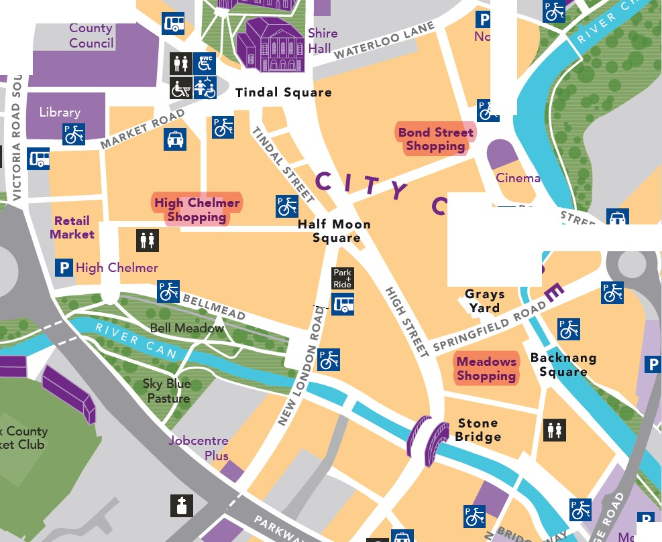

'Anne **llillilil**

Knight

Building

II

**[f1**

**m**

No.1

***C*** *•o•o s•,•***f***•***fl**

*>-*

**Mead01**

**m**